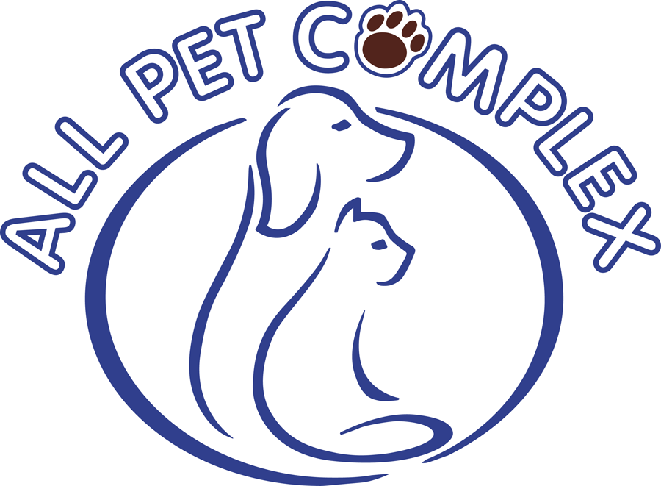
My Pet has Diarrhea. Why? What does it mean? Should I be concerned?

Written by Dr. Tim Warner – All Pet Complex

Why is diarrhea important? It is an indicator of the health of your animal and can illustrate either minor or more severe issues with your pet. Let us know if your pet is currently experiencing diarrhea when dropping off for their stay with us at Emerald Street Kennels. We will be sure to monitor it and help determine if veterinary help is necessary during your pet’s stay.

Diarrhea has many causes. First of all infectious diseases such as Parvovirus can lead to explosive bloody diarrhea. Parvo is a virus transmitted through infected stool and can become a problem in a kennel situation. This is why we require current vaccinations on all pets kenneled at our facility and employ rigorous cleaning and sanitation protocols to protect your pet. Gastrointestinal parasites including roundworms, hookworms, whipworms, coccidiosis, Giardia, etc. are contagious diseases also passed via a fecal oral route. We recommend that your pet have regular fecal testing done with your veterinarian and practice consistent deworming. Products like Interceptor and Heartguard Plus are heartworm preventatives but will also prevent the first three parasites mentioned above. Dietary indiscretion, sudden changes in food, new treats, etc. are also common causes of loose stools. We recommend that you bring your dog or cat’s own food with your pet to help keep their intestinal system happy. There is stress involved for any animal when they stay in a kennel and we want to eliminate as many variables as we can that can disrupt your pet. This stress can put your pet’s system out of balance and allow an underlying asymptomatic issue such as a parvovirus infection, roundworm infection, inflammatory bowel condition, underlying kidney or liver disease, dormant Clostridium perfringens enterotoxin gene, etc. to become a factor. Stress and dehydration can also lead to hemorrhagic gastroenteritis syndrome and gastric dilatation and volvulus (bloat). We employ safe play and chew toys here at Emerald Street Kennels to minimize the risk of a foreign body intestinal obstruction as well.

If your pet develops diarrhea during their stay we will notify you of this and if it becomes severe or your pet becomes lethargic and/or stops eating we will seek veterinary care for them. We want you, our clients, to be aware of the many factors that cause diarrhea so you can do your part to minimize this issue and help us keep your pet healthy during their stay. Please contact us if you have questions or contact your veterinarian.

All Pet Complex . 7660 Horseshoe Bend Rd. Boise, ID 83714 . (208)853-1000

